Problem Statement: Online Library Management System

Objective:
Design and implement a Java Web Application to manage a simple online library where users can search for books, borrow or return them, and administrators can add/update/remove book records.

Core Requirements:

Guest Features:
- Create Home page with all NEW books (workshop1 – 5 marks )
- Search books by title, author, or category(workshop1 – 5 marks )
- View Book’s detail (workshop2 – 5 marks )
- Register (workshop2 – 5 marks )

User Features:
- Login, logout (workshop1 – 5 marks )
- Change profile (workshop1 – 5 marks )
- Search for books by title, author, or category. (workshop2 – 5 marks )
- View book availability. (workshop2 – 5 marks )
- Request to borrow or return a book. (assignment –5 marks )
- View borrow history (assignment – 5 marks )

Admin Features:
- Log in to an admin panel & logout. (workshop1 – 5 marks )
- Setup system config : Overdue fine, book return time, book’s borrow unit price (workshop 1- 5 marks )
- Add new books to the system, edit or soft remove existing books. (workshop2 – 5 marks )
- View all borrow/return requests, approve or reject them and calculate overdue fine. (assignment-10 marks)
- Search the account by email and disable/enable the user’s account (workshop2-5 marks)
- View the list of books that are overdue (assignment-5 marks )
- Update inventory (assignment-5 marks )

Khong co lam :(
- statistics page: (assignment-5marrks)
  - Total Books Total number of books in the library
  - Total Users Number of registered users
  - Currently Borrowed Books Count of books currently checked out
  - Most Borrowed Books Top 5 books borrowed the most
  - Monthly Borrowing Stats Bar chart showing borrow count per month
  - Average Borrow Duration Average time a book is kept before returning

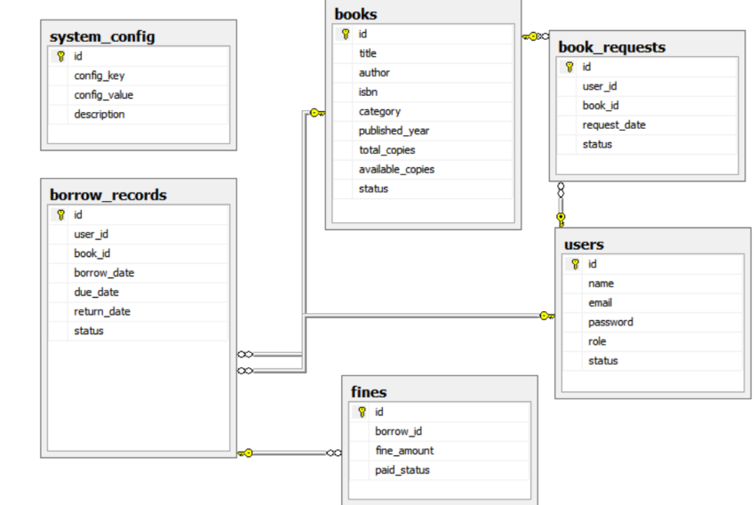
Database diagram
Rules:
- The group includes : 2-3 students
- Project evaluation will begin in the first day of week 9. Teacher will randomly call groups to present, and any group that is called but does not present will receive a score of 0.
- Each student must complete Workshop 1, Workshop 2, and the assignment. If any part is missing, the score for that component will be 0.
- Total 10/student
The End

